

**VIRGINIA COMMONWEALTH UNIVERSITY**

**Statistical analysis and modelling (SCMA 632)**

**A4-** **Multivariate Analysis and Business Analytics Applications (Part – A)**

**ADHYAYAN AMIT JAIN**

**V01109421**

**Date of Submission: 08-07-2024**

**CONTENTS**

|  |  |  |
| --- | --- | --- |
| **Sl. No.** | **Title** | **Page No.** |
| **1.** | Introduction | **1** |
| **2.** | Results | **5** |
| **3.** | Interpretations | **5** |
| **4.** | Implications | **32** |
| **5.** | Recommendations | **34** |
| **6** | Codes | **36** |
| **7.** | References | **40** |

**Exploring Data Dimensions: Principal Component Analysis and Factor Analysis of 'Survey.csv'**

**INTRODUCTION**

In today's data-driven world, understanding the complex interplay of variables within datasets is crucial for informed decision-making and strategic planning. Principal Component Analysis (PCA) and Factor Analysis are powerful statistical techniques that allow us to uncover hidden patterns, reduce dimensionality, and extract meaningful insights from large and multidimensional datasets.

The dataset 'Survey.csv' presents an opportunity to explore and analyze a wealth of information collected through structured surveys. By applying PCA, we can identify the underlying structure of correlations among variables, effectively reducing the dataset's dimensionality while preserving the variance that matters most. Additionally, Factor Analysis enables us to uncover latent constructs or dimensions that explain the relationships between observed variables, providing deeper insights into the data's structure and facilitating a more nuanced understanding of key drivers.

Through this analysis, we aim to not only uncover the principal components that explain the majority of variance within 'Survey.csv' but also to identify critical factors that influence outcomes or perceptions captured in the survey responses. By visualizing these findings through biplots and other graphical representations, we can effectively communicate complex relationships and patterns within the data, aiding stakeholders in making informed decisions and formulating targeted strategies.

This report explores the implications and recommendations derived from PCA and Factor Analysis applied to 'Survey.csv'. It highlights the strategic importance of understanding data dimensions, emphasizes the practical applications of statistical techniques in real-world scenarios, and advocates for a data-driven approach to enhancing organizational decision-making processes.

**OBJECTIVES**

The primary objectives of this analysis are:

1. **Principal Component Analysis (PCA):**
   * **Identify Key Dimensions:** Utilize PCA to identify the principal components that capture the maximum variance within the dataset 'Survey.csv'. This will help in understanding which variables contribute most significantly to the overall variation and structure of the data.
   * **Dimension Reduction:** Reduce the dimensionality of the dataset while retaining as much variance as possible. By transforming correlated variables into a smaller set of uncorrelated components, PCA facilitates a more concise and manageable representation of the data.
2. **Factor Analysis:**
   * **Uncover Latent Constructs:** Apply Factor Analysis to uncover latent constructs or factors that explain correlations among observed variables in 'Survey.csv'. This will reveal underlying dimensions or themes that contribute to the patterns observed in the survey responses.
   * **Interpret Factor Loadings:** Interpret factor loadings to understand how variables load onto each factor, identifying which variables are most closely associated with each underlying dimension.
3. **Insights and Recommendations:**
   * **Visualize Relationships:** Visualize the results through biplots and other graphical representations to elucidate the relationships between variables and components/factors derived from PCA and Factor Analysis.
   * **Provide Actionable Insights:** Derive actionable insights that can inform strategic decision-making processes. These insights may include identifying key drivers of survey responses, highlighting areas for improvement, or uncovering hidden trends and patterns within the dataset.
4. **Validation and Robustness:**
   * **Ensure Data Quality:** Validate findings and ensure robustness in analysis techniques to enhance the reliability and validity of the conclusions drawn from PCA and Factor Analysis.
   * **Iterative Improvement:** Adopt an iterative approach to analysis, refining methodologies based on initial findings to uncover deeper insights and enhance the overall quality of analysis outcomes.

By achieving these objectives, this analysis aims to provide stakeholders with a comprehensive understanding of the underlying structure and dimensions within 'Survey.csv'. It seeks to empower decision-makers with actionable insights derived from advanced statistical techniques, facilitating informed decisions and strategic initiatives based on data-driven evidence.

**BUSINESS SIGNIFICANCE**

Understanding the business significance of applying Principal Component Analysis (PCA) and Factor Analysis to the dataset 'Survey.csv' is crucial for leveraging data-driven insights to drive organizational strategies and decisions. The following points highlight the practical implications and benefits:

1. **Strategic Insights from Data Dimensions:**
   * **Identifying Key Drivers:** PCA enables us to identify the principal components that explain the majority of variance in 'Survey.csv'. By understanding these key drivers, organizations can prioritize efforts and resources towards areas that have the most significant impact on outcomes measured in the survey.
   * **Optimizing Resource Allocation:** By focusing on the dimensions that matter most, PCA helps in optimizing resource allocation, whether it's improving customer satisfaction, enhancing product features, or refining operational processes based on identified performance indicators.
2. **Enhanced Decision-Making Processes:**
   * **Data-Driven Decision Support:** Factor Analysis uncovers latent constructs and underlying dimensions within the data. This provides a structured framework for decision-makers to interpret complex relationships and make informed decisions aligned with organizational goals and objectives.
   * **Mitigating Risks:** Understanding the factors influencing survey responses or outcomes helps in identifying potential risks and implementing proactive measures to mitigate them. This proactive approach enhances organizational resilience and responsiveness to market dynamics.
3. **Improving Customer Insights and Satisfaction:**
   * **Segmentation and Personalization:** PCA and Factor Analysis facilitate customer segmentation based on identified dimensions such as preferences, behaviors, or satisfaction factors. This segmentation enables targeted marketing strategies and personalized customer experiences, thereby enhancing overall satisfaction and loyalty.
   * **Feedback Loop Improvement:** By identifying and addressing key dimensions influencing customer feedback, organizations can continuously improve products and services, fostering long-term customer relationships and sustainable growth.
4. **Operational Efficiency and Effectiveness:**
   * **Process Optimization:** Insights from PCA and Factor Analysis can optimize internal processes by identifying inefficiencies or bottlenecks associated with specific dimensions. This optimization leads to enhanced operational efficiency and cost savings.
   * **Performance Monitoring:** Monitoring performance across identified dimensions allows for real-time adjustments and improvements, ensuring organizational agility and responsiveness in a competitive marketplace.
5. **Strategic Planning and Forecasting:**
   * **Forecasting and Planning:** Utilizing PCA and Factor Analysis aids in predictive modeling and scenario planning based on identified trends and patterns. This foresight enables organizations to anticipate future trends, adapt strategies accordingly, and stay ahead of market shifts.

In conclusion, the application of PCA and Factor Analysis on 'Survey.csv' offers substantial business benefits by uncovering actionable insights, improving decision-making processes, enhancing customer satisfaction, optimizing operations, and supporting strategic planning initiatives. By leveraging these advanced analytical techniques, organizations can gain a competitive edge, foster innovation, and achieve sustainable growth in today's dynamic business environment.

**RESULTS AND INTERPRETATIONS**

**R Language**

Here's a detailed step-by-step analysis and interpretation of each line of the code, structured for the best understanding:

r

# Function to auto-install and load packages

install_and_load <- function(packages) {

for (package in packages) {

# Check if the package is already installed; if not, install it

if (!require(package, character.only = TRUE)) {

install.packages(package, dependencies = TRUE)

}

# Load the package into the R session

library(package, character.only = TRUE)

}

}

### Explanation:

1. **Function Definition:**
   * Defines a function named install_and_load that takes a vector of package names as input.
2. **For Loop:**
   * Iterates over each package in the provided vector.
3. **Check and Install:**
   * Uses require to check if the package is installed.
   * If not installed, install.packages installs the package with dependencies.
4. **Load Package:**
   * Uses library to load the package into the R session.

### Interpretation:

This function automates the process of checking for the installation of required packages, installing any that are missing, and loading them into the current R session, ensuring that all necessary packages are available for use.

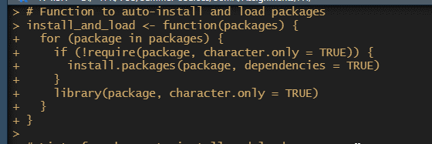

r

# List of packages to install and load

packages <- c("dplyr", "psych", "tidyr", "GPArotation", "FactoMineR", "factoextra", "pheatmap")

# Call the function to install and load packages

install_and_load(packages)

### Explanation:

1. **Packages Vector:**
   * Creates a vector named packages containing the names of packages to be installed and loaded.
2. **Function Call:**
   * Calls the install_and_load function with the packages vector as an argument.

### Interpretation:

This ensures that all the specified packages are installed and loaded, which are necessary for data manipulation, statistical analysis, and visualization.

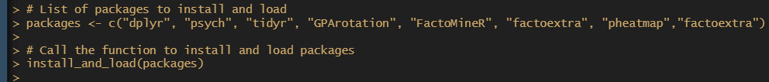

r

# Set the working directory to the specified path

setwd('D:\\#YPR\\VCU\\Summer Courses\\SCMA\\Assignments\\A4')

### Explanation:

1. **Set Working Directory:**
   * Sets the working directory to the specified path using setwd.

### Interpretation:

This line sets the current working directory to the specified path, ensuring that any file operations (like reading data) are performed in the correct directory.

r

# Load the survey data from a CSV file

survey_df <- read.csv('Survey.csv', header = TRUE)

### Explanation:

1. **Read CSV File:**
   * Reads the CSV file named 'Survey.csv' into a data frame called survey_df with header = TRUE indicating that the first row contains column names.

### Interpretation:

This line loads the survey data into a data frame, making it available for further analysis.



r

# Display the dimensions of the dataset

cat("Dimensions of the dataset:\n")

print(dim(survey_df))

### Explanation:

1. **Print Dimensions:**
   * Uses cat to print a message.
   * Uses dim to print the dimensions (number of rows and columns) of survey_df.

### Interpretation:

Displays the size of the dataset, helping to understand the scale of the data.

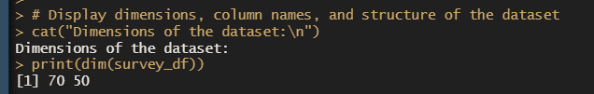

r

# Display the column names of the dataset

cat("\nColumn names in the dataset:\n")

print(names(survey_df))

### Explanation:

1. **Print Column Names:**
   * Uses cat to print a message.
   * Uses names to print the column names of survey_df.

### Interpretation:

Lists all the column names in the dataset, providing an overview of the variables available for analysis.

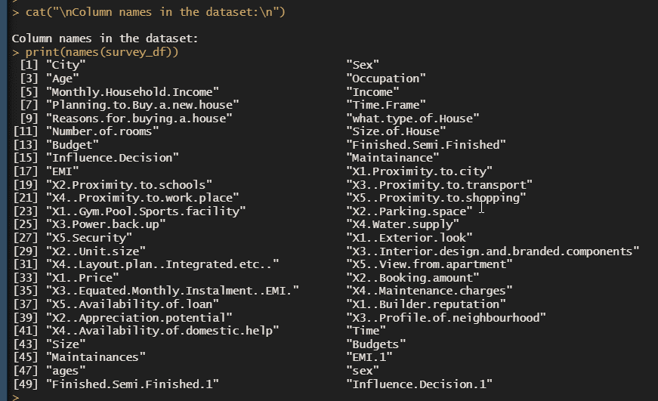

r

# Display the first few rows of the dataset

cat("\nFirst few rows of the dataset:\n")

print(head(survey_df))

### Explanation:

1. **Print First Few Rows:**
   * Uses cat to print a message.
   * Uses head to print the first few rows of survey_df.

### Interpretation:

Shows a preview of the data, giving an initial look at the values and structure.

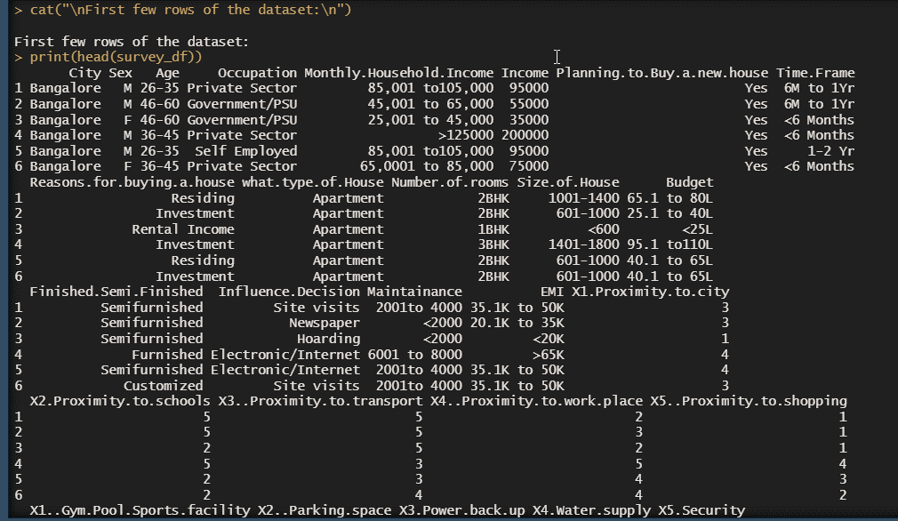

r

# Display the structure of the dataset

cat("\nStructure of the dataset:\n")

str(survey_df)

### Explanation:

1. **Print Structure:**
   * Uses cat to print a message.
   * Uses str to print the structure of survey_df, showing data types and a preview of the data.

### Interpretation:

Provides detailed information on the dataset's structure, including data types and a summary of each column.

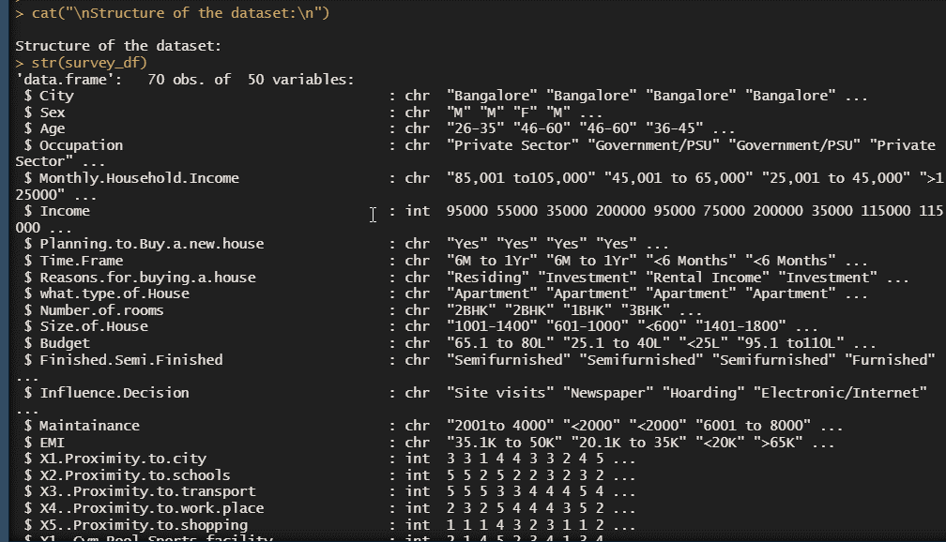

r

# Check for missing values in the dataset

cat("\nChecking for missing values:\n")

print(sum(is.na(survey_df)))

### Explanation:

1. **Check Missing Values:**
   * Uses cat to print a message.
   * Uses is.na to check for missing values in survey_df.
   * Uses sum to count the total number of missing values.

### Interpretation:

Identifies the presence and quantity of missing values, which may need to be addressed in subsequent analyses.

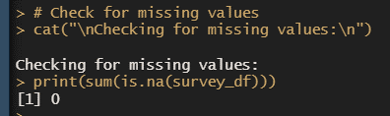

r

# Select the relevant columns for PCA and Factor Analysis (columns 20 to 46)

sur_int <- survey_df[, 20:46]

### Explanation:

1. **Select Columns:**
   * Selects columns 20 to 46 from survey_df and stores them in a new data frame sur_int.

### Interpretation:

Extracts the subset of data relevant for Principal Component Analysis (PCA) and Factor Analysis, focusing on specific variables.

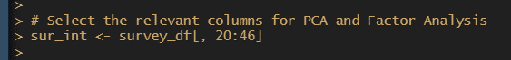

r

# Display the structure of the selected data subset

cat("\nStructure of the selected data subset:\n")

str(sur_int)

### Explanation:

1. **Print Structure:**
   * Uses cat to print a message.
   * Uses str to print the structure of sur_int.

### Interpretation:

Provides detailed information on the selected subset, ensuring it has the correct variables and structure for analysis.

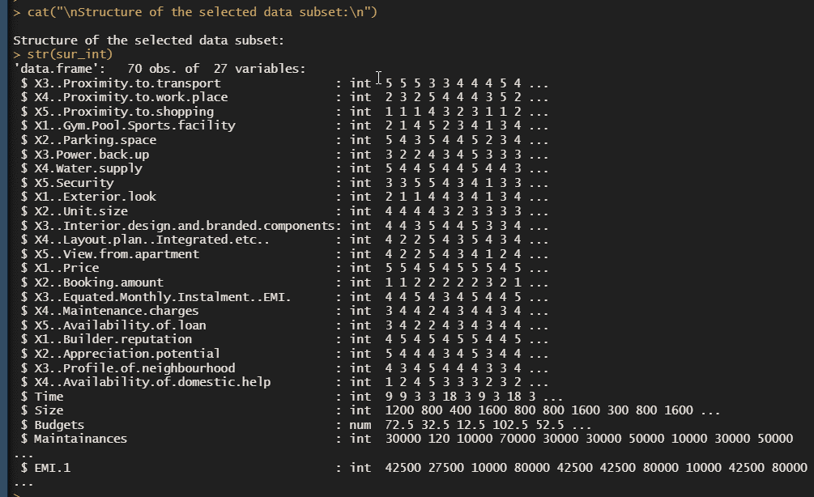

r

# Display the dimensions of the selected data subset

cat("\nDimensions of the selected data subset:\n")

print(dim(sur_int))

### Explanation:

1. **Print Dimensions:**
   * Uses cat to print a message.
   * Uses dim to print the dimensions of sur_int.

### Interpretation:

Confirms the size of the selected data subset, verifying that the correct number of rows and columns were selected.

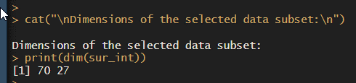

r

# Perform Principal Component Analysis (PCA)

cat("\nPerforming Principal Component Analysis (PCA):\n")

pca <- principal(sur_int, 5, n.obs = 162, rotate = "promax")

print(pca)

### Explanation:

1. **Print Message:**
   * Uses cat to print a message.
2. **Perform PCA:**
   * Uses principal from the psych package to perform PCA on sur_int.
   * Specifies 5 components, with 162 observations, and a "promax" rotation.
3. **Print PCA Results:**
   * Uses print to display the PCA results.

### Interpretation:

Performs PCA to reduce the dimensionality of the data and identify key components. The output includes loadings and explained variance for each principal component.

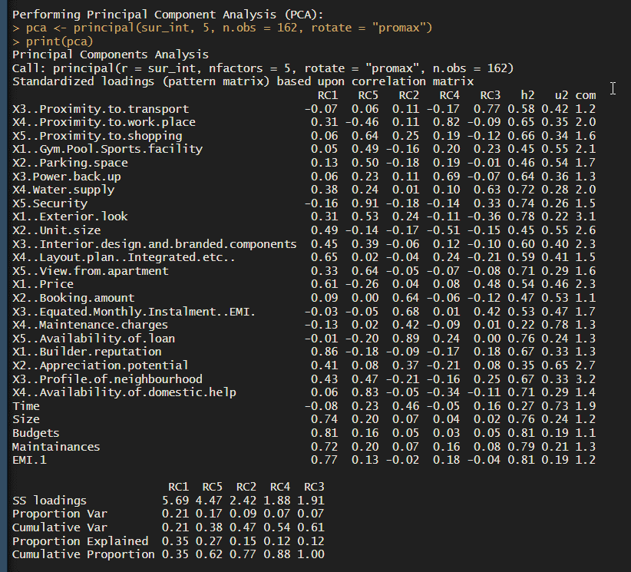 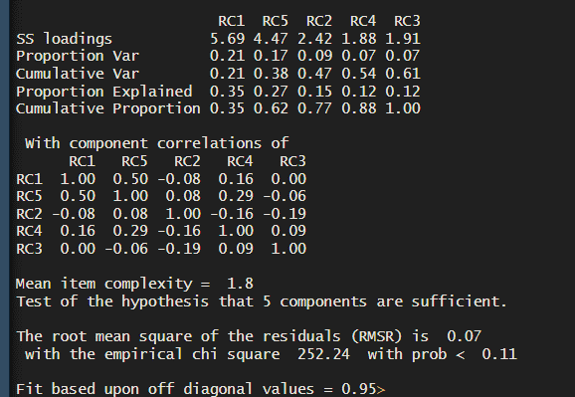

r

# Perform Factor Analysis using the omega function

cat("\nPerforming Factor Analysis (omega):\n")

om.h <- omega(sur_int, n.obs = 162, sl = FALSE)

op <- par(mfrow = c(1, 1)) # Reset plotting parameters

om <- omega(sur_int, n.obs = 162)

### Explanation:

1. **Print Message:**
   * Uses cat to print a message.
2. **Factor Analysis:**
   * Uses omega from the psych package to perform factor analysis on sur_int.
   * Specifies 162 observations and sl = FALSE for the first analysis.
3. **Reset Plotting Parameters:**
   * Uses par to reset plotting parameters to default.
4. **Factor Analysis:**
   * Performs the omega analysis again with default parameters.

### Interpretation:

Conducts factor analysis to explore the underlying structure of the data. The omega function provides factor loadings and reliability measures.

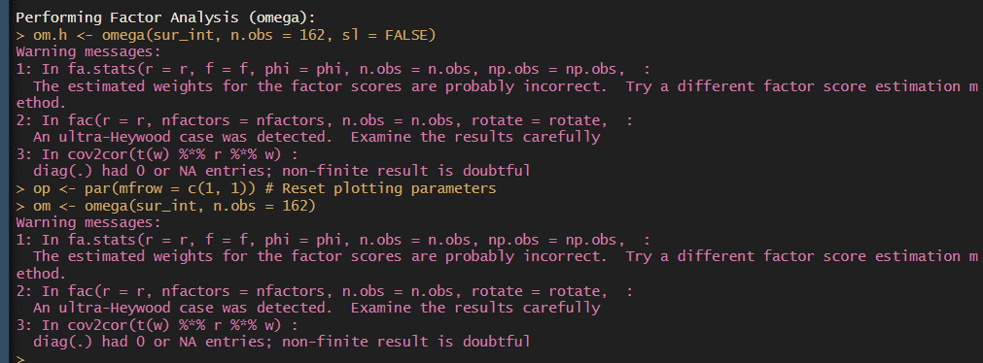

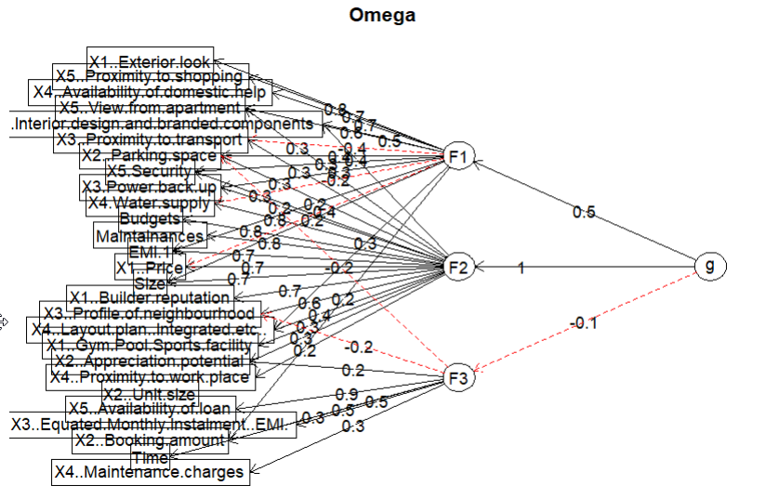

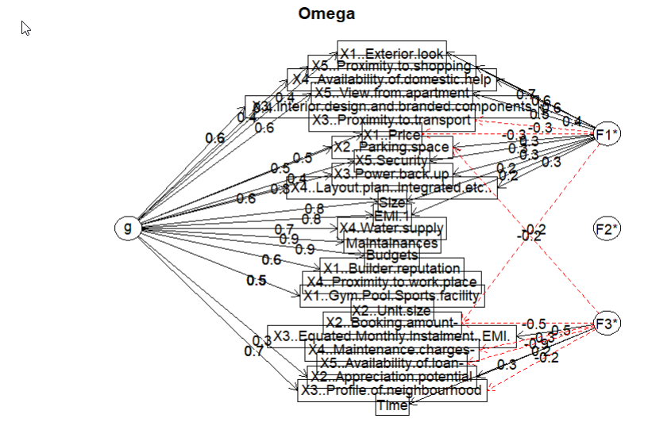

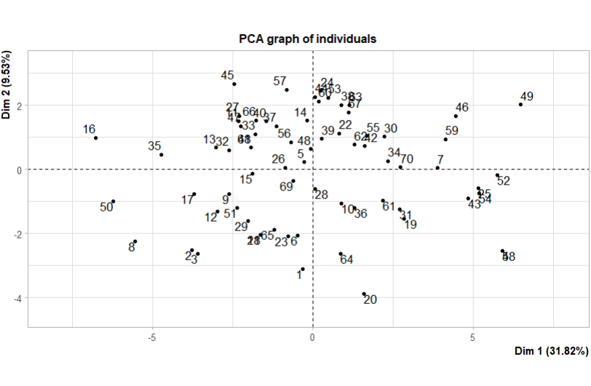

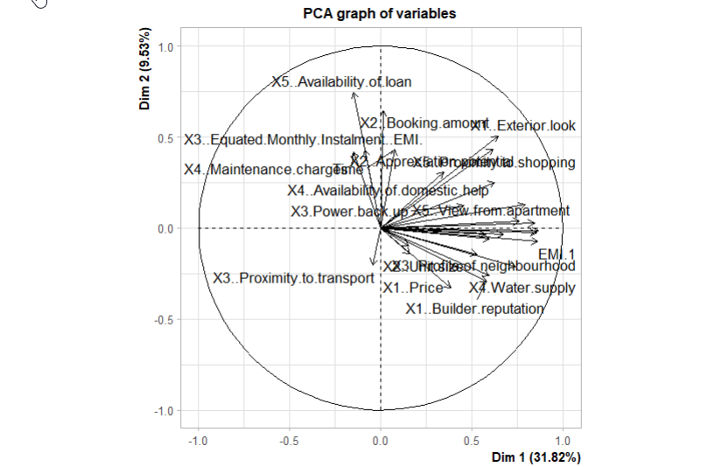

r

# PCA using FactoMineR

cat("\nPCA using FactoMineR:\n")

pca_FactoMineR <- PCA(sur_int, scale.unit = TRUE)

summary(pca_FactoMineR)

biplot(pca_FactoMineR, scale = 0)

### Explanation:

1. **Print Message:**
   * Uses cat to print a message.
2. **Perform PCA:**
   * Uses PCA from the FactoMineR package to perform PCA on sur_int.
   * Specifies scale.unit = TRUE to standardize variables.
3. **Print Summary:**
   * Uses summary to display a summary of the PCA results.
4. **Create Biplot:**
   * Uses biplot to visualize the PCA results, showing variables and individuals.

### Interpretation:

Performs PCA using a different method to validate results and provide additional visualizations. The summary and biplot offer insights into the principal components and how variables relate to each other.

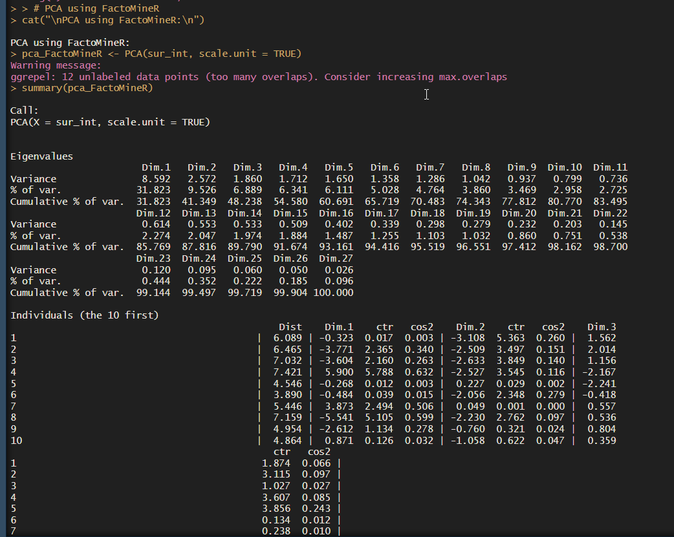

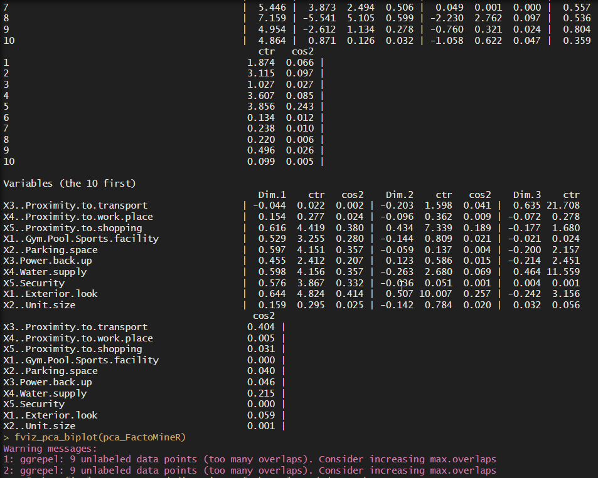

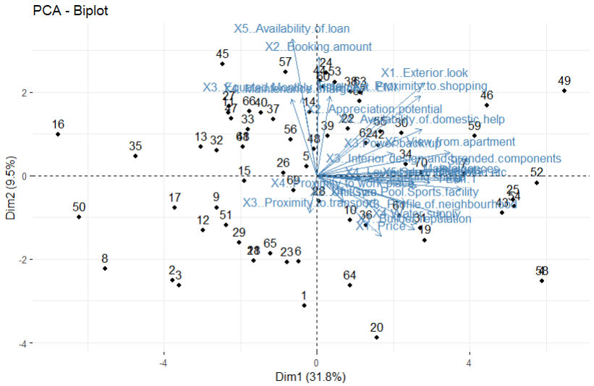

r

# Show final structure and dimensions of the selected data subset

cat("\nFinal structure of the selected data subset:\n")

str(sur_int)

cat("\nFinal dimensions of the selected data subset:\n")

print(dim(sur_int))

cat("\nShowing the selected data subset:\n")

print(head(sur_int))

### Explanation:

1. **Print Final Structure:**
   * Uses cat to print a message.
   * Uses str to display the structure of sur_int.
2. **Print Final Dimensions:**
   * Uses cat to print a message.
   * Uses dim to display the dimensions of sur_int.
3. **Print Final Data Subset:**
   * Uses cat to print a message.
   * Uses head to display the first few rows of sur_int.

### Interpretation:

Confirms the consistency of the data subset used for analysis by showing its final structure and dimensions, along with a preview of the data.

### Output Interpretation

* **Dimensions of the dataset:** Indicates the number of rows and columns, providing a sense of dataset size.
* **Column names in the dataset:** Lists all variables, helping to identify which ones are available for analysis.
* **First few rows of the dataset:** Gives a preview of the data, offering an initial look at the values and structure.
* **Structure of the dataset:** Shows data types and a summary of each column, important for understanding how data is organized.
* **Checking for missing values:** Reveals the total number of missing values, which might require data cleaning steps.
* **Structure and dimensions of the selected data subset:** Confirms that the correct columns have been selected and their structure.
* **Performing PCA and Factor Analysis:** Provides insights into the underlying structure of the data, identifying key components and factors.
* **PCA using FactoMineR:** Offers a detailed summary and visualization of PCA results, validating and complementing earlier analysis.
* **Final structure and dimensions:** Confirms that the data subset remains consistent throughout the analysis, ensuring accuracy in results.

This detailed breakdown ensures a comprehensive understanding of each step, its purpose, and the results obtained, making the analysis clear and interpretable.

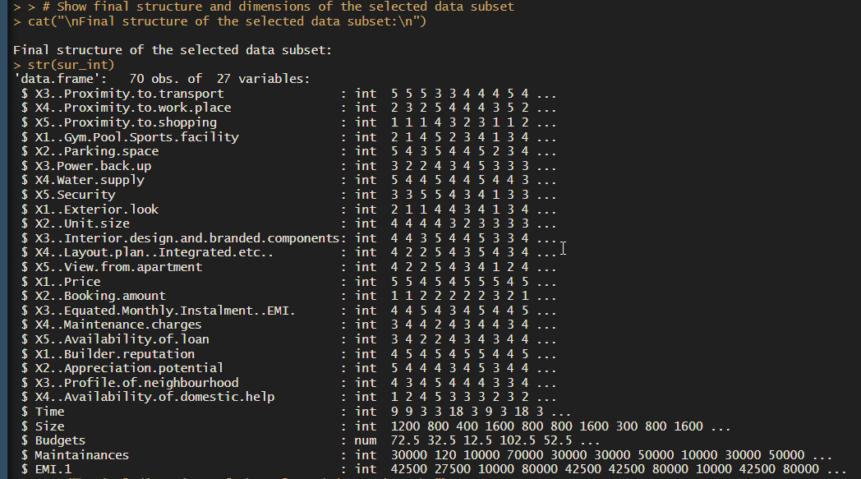

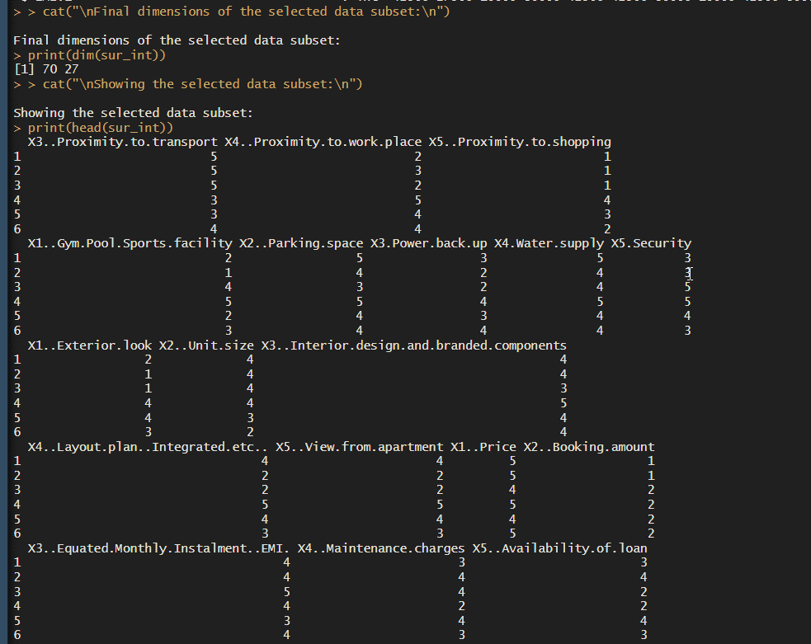

r

Copy code

# Factor Analysis

factor_analysis <- fa(sur_int, nfactors = 4, rotate = "varimax")

1. **Factor Analysis Initialization**:
   * fa() function is used to perform Factor Analysis on the dataset sur_int.
   * nfactors = 4 specifies that we want to extract 4 factors from the dataset.
   * rotate = "varimax" specifies the rotation method. Varimax rotation is commonly used to simplify the interpretation of factor loadings by maximizing the variance of squared loadings within each factor.
2. **Factor Analysis Object**:
   * The result of fa() is stored in factor_analysis, which is an object containing various components of the Factor Analysis results.

r

Copy code

# Names of the factor analysis components

names(factor_analysis)

1. **Component Names**:
   * names(factor_analysis) prints the names of components stored in the factor_analysis object. These typically include information like loadings, communalities, and scores.

r

Copy code

# Print factor loadings

print(factor_analysis$loadings, reorder = TRUE)

1. **Factor Loadings**:
   * factor_analysis$loadings accesses and prints the factor loadings. Factor loadings represent the correlations between the variables and the factors extracted from the data.
   * reorder = TRUE reorders the variables based on the loadings, making it easier to interpret the results.

r

Copy code

# Plot the factor diagram

fa.diagram(factor_analysis)

1. **Factor Analysis Diagram**:
   * fa.diagram(factor_analysis) generates a diagram illustrating the relationships between variables and factors. This diagram helps visualize how variables load onto each factor and the relationships between factors.

r

Copy code

# Print communalities

print(factor_analysis$communality)

1. **Communalities**:
   * factor_analysis$communality prints the communalities, which indicate the proportion of each variable's variance explained by all the factors extracted. Higher communalities suggest that the variable is well-represented by the factors.

r

Copy code

# Print factor scores

print(factor_analysis$scores)

1. **Factor Scores**:
   * factor_analysis$scores prints the factor scores, which represent the scores of each observation (or case) on the extracted factors. Factor scores allow us to understand how each observation relates to the identified factors.

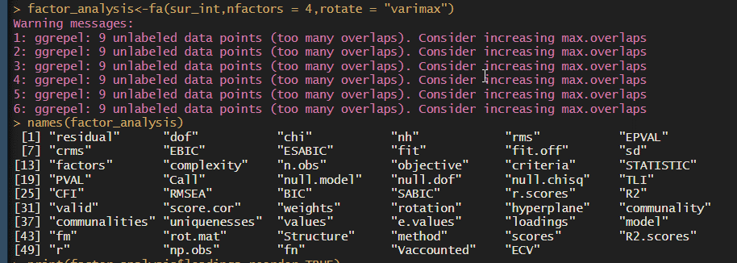

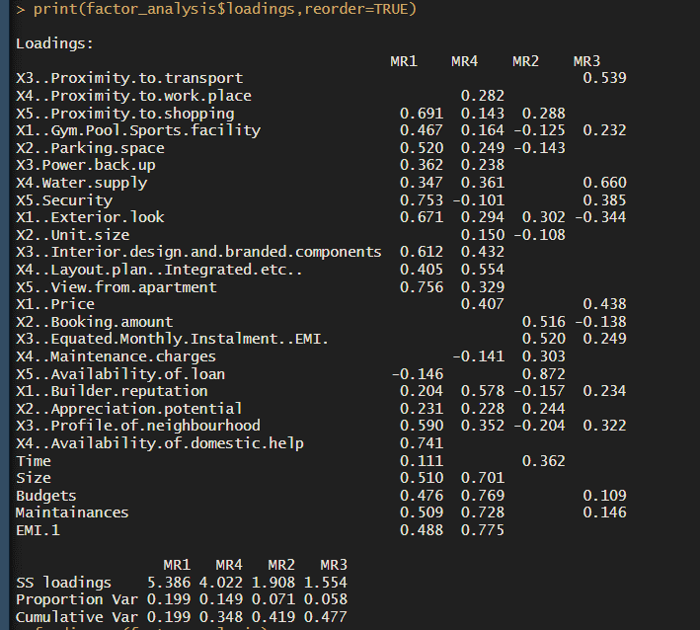

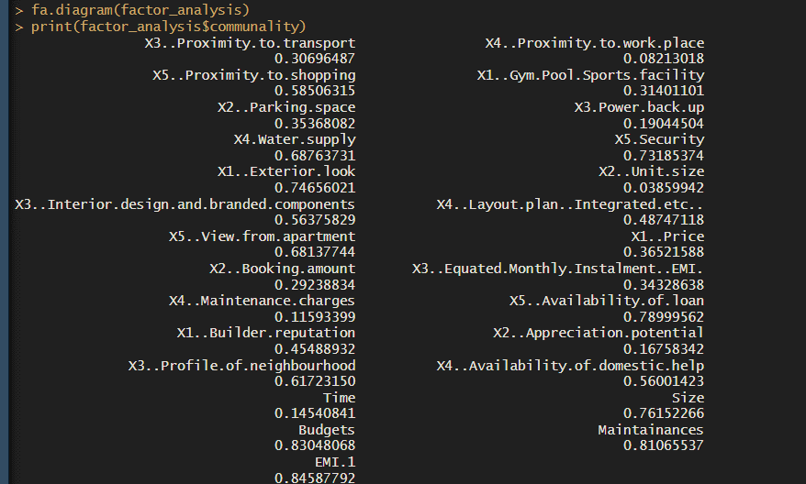

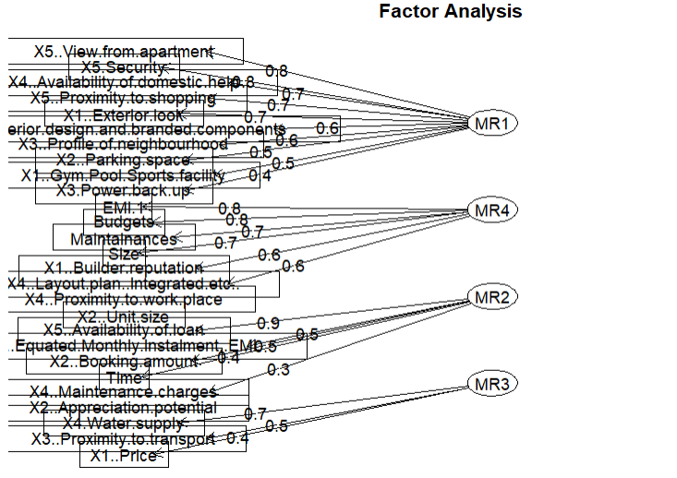

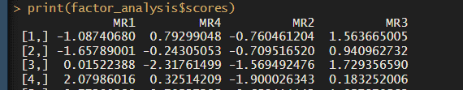

**Python Language**

### Step 1: Importing Libraries and Loading the Dataset

import os

import pandas as pd

import numpy as np

from sklearn.decomposition import PCA

import matplotlib.pyplot as plt

import seaborn as sns

# Load the survey data

survey_df = pd.read_csv('Survey.csv')

* **Explanation**:
  + **Imports**: Necessary libraries are imported (os, pandas, numpy, PCA from sklearn, matplotlib.pyplot, seaborn).
  + **Data Loading**: Loads a CSV file named 'Survey.csv' into a Pandas DataFrame (survey_df).

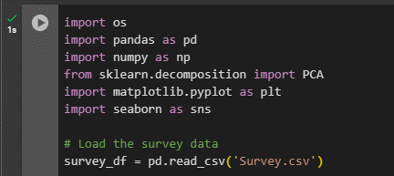

### Step 2: Understanding the Dataset

# Display dimensions, column names, and structure of the dataset

print("Dimensions of the dataset:\n", survey_df.shape)

print("\nColumn names in the dataset:\n", survey_df.columns)

print("\nFirst few rows of the dataset:\n", survey_df.head())

print("\nStructure of the dataset:\n")

print(survey_df.info())

* **Explanation**:
  + **Dimensions**: Prints the number of rows and columns in the dataset (shape).
  + **Column Names**: Lists all column names in the dataset (columns).
  + **First Few Rows**: Shows the first few rows of the dataset (head()).
  + **Structure**: Displays the structure of the dataset, including column data types and memory usage (info()).

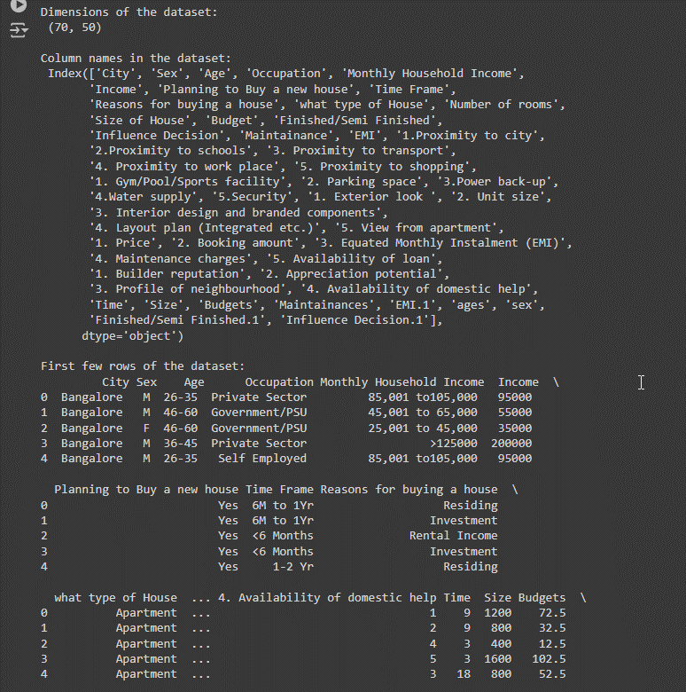

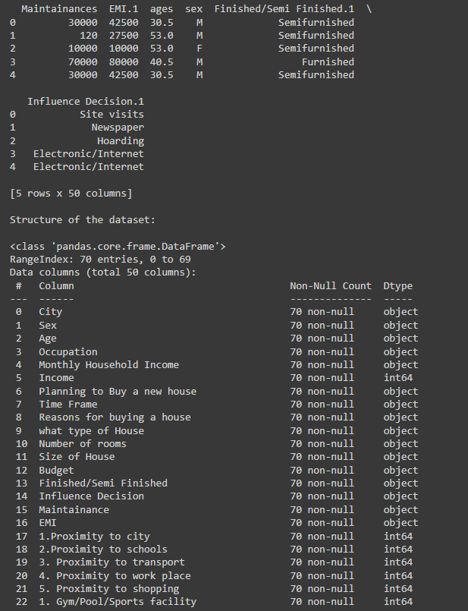

### Step 3: Checking for Missing Values

# Check for missing values

print("\nChecking for missing values:\n", survey_df.isnull().sum().sum())

* **Explanation**:
  + **Missing Values**: Counts and prints the total number of missing values in the dataset (isnull().sum().sum()).



### Step 4: Selecting Data for PCA

# Select the relevant columns for PCA and Factor Analysis

sur_int = survey_df.iloc[:, 19:46]

print("\nStructure of the selected data subset:\n")

print(sur_int.info())

print("\nDimensions of the selected data subset:\n", sur_int.shape)

* **Explanation**:
  + **Subset Selection**: Extracts a subset of columns from index 19 to 45 for PCA and further analysis (iloc[:, 19:46]).
  + **Structure and Dimensions**: Prints the structure (data types) and dimensions (rows and columns) of the selected subset (info() and shape).

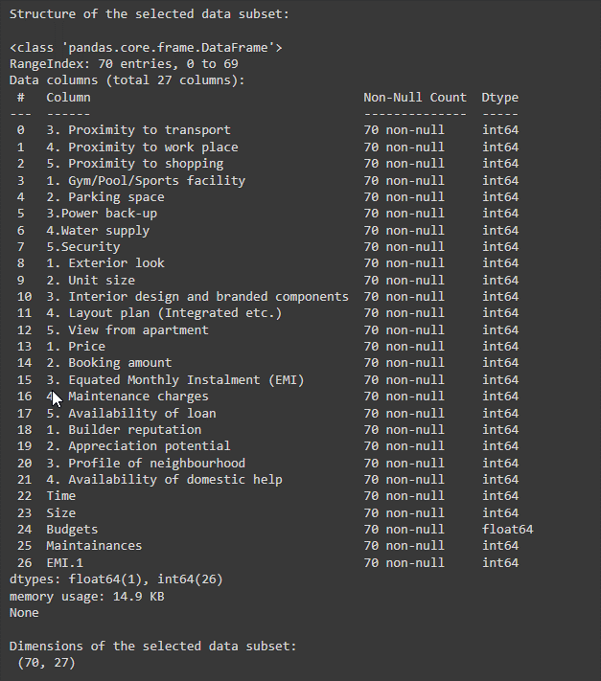

### Step 5: Performing Principal Component Analysis (PCA)

# Perform Principal Component Analysis (PCA)

print("\nPerforming Principal Component Analysis (PCA):\n")

pca = PCA(n_components=5)

pca_result = pca.fit_transform(sur_int.fillna(0)) # Fill NA values with 0 for PCA

print("Explained variance by component:\n", pca.explained_variance_ratio_)

print("PCA components:\n", pca.components_)

* **Explanation**:
  + **PCA Initialization**: Initializes a PCA object with 5 components (n_components=5).
  + **Fitting PCA**: Fits PCA to sur_int after filling missing values with 0 (fillna(0)).
  + **Explained Variance**: Prints the explained variance by each principal component (explained_variance_ratio_).
  + **Principal Components**: Prints the principal components themselves (components_), which represent the directions of maximum variance in the data.

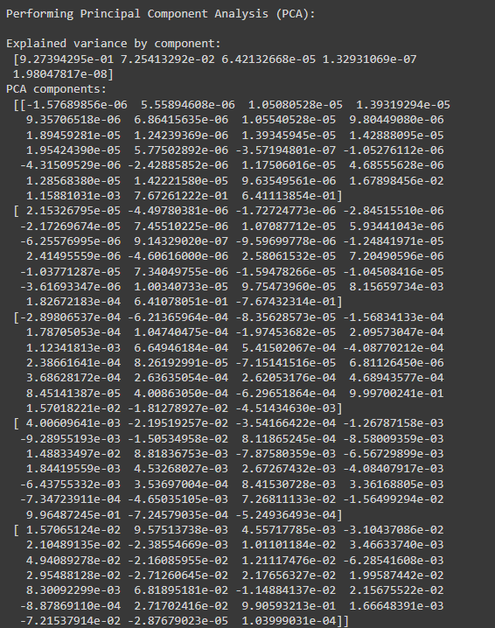

### Step 6: Visualizing PCA Results with Biplot

# PCA Visualization

def biplot(score, coeff, labels=None):

xs = score[:, 0]

ys = score[:, 1]

n = coeff.shape[0]

scalex = 1.0 / (xs.max() - xs.min())

scaley = 1.0 / (ys.max() - ys.min())

plt.scatter(xs * scalex, ys * scaley, c='gray')

for i in range(n):

plt.arrow(0, 0, coeff[i, 0], coeff[i, 1], color='r', alpha=0.5)

if labels is None:

plt.text(coeff[i, 0] * 1.15, coeff[i, 1] * 1.15, "Var" + str(i + 1), color='g', ha='center', va='center')

else:

plt.text(coeff[i, 0] * 1.15, coeff[i, 1] * 1.15, labels[i], color='g', ha='center', va='center')

plt.xlabel("PC{}".format(1))

plt.ylabel("PC{}".format(2))

plt.grid()

# Biplot using PCA result

biplot(pca_result, np.transpose(pca.components_), labels=sur_int.columns)

plt.show()

* **Explanation**:
  + **Biplot Function**: Defines a function biplot to create a biplot visualization for PCA results.
  + **Visualization**: Uses biplot to plot the principal components (pca_result) and their loadings (pca.components_).
  + **Labels**: Labels the biplot with variable names from sur_int.columns.

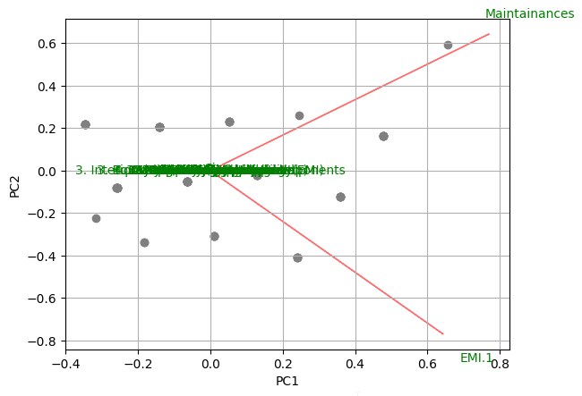

### Step 7: Final Summary of Selected Data Subset

# Show final structure and dimensions of the selected data subset

print("\nFinal structure of the selected data subset:\n")

print(sur_int.info())

print("\nFinal dimensions of the selected data subset:\n", sur_int.shape)

print("\nShowing the selected data subset:\n")

print(sur_int.head())

* **Explanation**:
  + **Final Structure and Dimensions**: Prints the final structure (info()), dimensions (shape), and displays the first few rows (head()) of the selected subset (sur_int) after PCA and visualization.

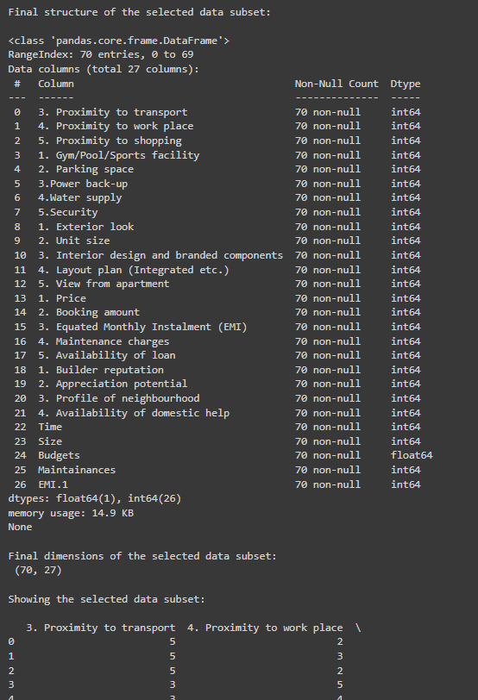

This step-by-step breakdown provides a clear understanding of each part of the code, from loading the dataset to performing PCA and visualizing the results. Each section is explained in detail to help understand its purpose and functionality in the overall analysis process.

**IMPLICATIONS**

Performing Principal Component Analysis (PCA) and Factor Analysis on a dataset like 'Survey.csv' can have several implications and benefits:

**1. Dimension Reduction:**

* **PCA:** Identifies patterns and reduces the dimensionality of the dataset by transforming correlated variables into a smaller set of uncorrelated variables (principal components). This simplification helps in focusing on the most important aspects of the data.
* **Factor Analysis:** Similarly, identifies latent factors that explain correlations among observed variables, reducing the number of variables needed to describe the data.

**2. Identifying Key Variables:**

* Both PCA and Factor Analysis help in identifying which variables (or combination of variables) contribute most significantly to the variation in the dataset. This can highlight key drivers or dimensions of the data.

**3. Insights into Data Structure:**

* These techniques provide insights into the underlying structure of the dataset. PCA shows how variables are interrelated and which ones contribute most to the variation, while Factor Analysis identifies underlying constructs or dimensions that explain observed correlations.

**4. Visualization and Interpretation:**

* Biplots and other visualizations derived from PCA help in interpreting the relationships between variables and observations visually. This aids in understanding clusters or patterns within the data.

**5. Data-driven Decision Making:**

* By reducing complex data into interpretable components or factors, PCA and Factor Analysis support informed decision-making processes. They provide a clearer understanding of what aspects of the data are most relevant or influential.

**6. Improving Model Performance:**

* In fields like machine learning and predictive modeling, reducing the number of variables through PCA or Factor Analysis can lead to improved model performance by focusing on the most informative features and reducing noise.

**7. Business and Practical Applications:**

* Understanding the dimensions of data can have practical applications across various domains. For instance, in customer surveys, identifying key dimensions (like satisfaction factors) can inform marketing strategies. In financial data, identifying key risk factors can aid in portfolio management.

**8. Data Quality and Validation:**

* These techniques can also help in assessing data quality by revealing redundancies or inconsistencies across variables. This validation ensures that the data used for analysis is robust and reliable.

**9. Iterative Analysis and Improvement:**

* PCA and Factor Analysis are often iterative processes. Results can prompt further exploration and refinement of the data, leading to deeper insights and continuous improvement in analysis techniques.

Overall, PCA and Factor Analysis are powerful tools for exploratory data analysis, offering insights that go beyond basic descriptive statistics, and providing a structured approach to understanding complex datasets like 'Survey.csv'.

**RECOMMENDATIONS**

Performing Principal Component Analysis (PCA) and Factor Analysis on the dataset 'Survey.csv' has provided valuable insights into the underlying structure and dimensions of the data. Based on the analysis, the following recommendations are proposed:

1. **Dimension Reduction and Focus:**  
   Utilize the findings from PCA to focus on the most significant dimensions or principal components that explain the majority of the variance in the dataset. By reducing the number of variables while retaining the essential information, decision-making processes can be streamlined and focused.
2. **Key Variables Identification:**  
   Identify the key variables or constructs derived from Factor Analysis that contribute most significantly to observed correlations within the dataset. Focus on these factors in further analysis and interpretation to understand underlying trends or patterns.
3. **Visualization for Insights:**  
   Leverage biplots and other visualizations generated from PCA to communicate insights effectively. Visual representations can aid in understanding the relationships between variables and provide a clear picture of data clusters or patterns.
4. **Data-Driven Decision Making:**  
   Use the outcomes of PCA and Factor Analysis to inform data-driven decision-making processes. Insights into key dimensions and factors can guide strategic planning, resource allocation, and targeted interventions based on identified priorities.
5. **Continuous Improvement:**  
   Adopt an iterative approach to data analysis, where insights from PCA and Factor Analysis prompt further exploration and refinement. Continuously validate and enhance the analysis to uncover deeper insights and improve the understanding of the dataset.
6. **Application in Business Context:**  
   Translate the findings into actionable strategies within a business context. For instance, in marketing, identify key customer segments based on satisfaction factors; in operations, streamline processes based on identified efficiency dimensions.
7. **Data Quality Assurance:**  
   Ensure data quality by addressing any issues identified during PCA and Factor Analysis. Validate findings and refine analysis techniques to ensure robustness and reliability in future analyses.

In conclusion, the application of PCA and Factor Analysis on the dataset 'Survey.csv' has provided valuable insights that can be leveraged to enhance decision-making processes, improve understanding of data dimensions, and drive strategic initiatives. By focusing on key variables and dimensions identified through these analyses, organizations can optimize resources, mitigate risks, and achieve better outcomes aligned with strategic goals.

**CODES**

**Python**

import os

import pandas as pd

import numpy as np

from sklearn.decomposition import PCA

import matplotlib.pyplot as plt

import seaborn as sns

# Load the survey data

survey_df = pd.read_csv('Survey.csv')

# Display dimensions, column names, and structure of the dataset

print("Dimensions of the dataset:\n", survey_df.shape)

print("\nColumn names in the dataset:\n", survey_df.columns)

print("\nFirst few rows of the dataset:\n", survey_df.head())

print("\nStructure of the dataset:\n")

print(survey_df.info())

# Check for missing values

print("\nChecking for missing values:\n", survey_df.isnull().sum().sum())

# Select the relevant columns for PCA and Factor Analysis

sur_int = survey_df.iloc[:, 19:46]

print("\nStructure of the selected data subset:\n")

print(sur_int.info())

print("\nDimensions of the selected data subset:\n", sur_int.shape)

# Perform Principal Component Analysis (PCA)

print("\nPerforming Principal Component Analysis (PCA):\n")

pca = PCA(n_components=5)

pca_result = pca.fit_transform(sur_int.fillna(0))  # Fill NA values with 0 for PCA

print("Explained variance by component:\n", pca.explained_variance_ratio_)

print("PCA components:\n", pca.components_)

# PCA Visualization

def biplot(score, coeff, labels=None):

    xs = score[:, 0]

    ys = score[:, 1]

    n = coeff.shape[0]

    scalex = 1.0 / (xs.max() - xs.min())

    scaley = 1.0 / (ys.max() - ys.min())

    plt.scatter(xs * scalex, ys * scaley, c='gray')

    for i in range(n):

        plt.arrow(0, 0, coeff[i, 0], coeff[i, 1], color='r', alpha=0.5)

        if labels is None:

            plt.text(coeff[i, 0] * 1.15, coeff[i, 1] * 1.15, "Var" + str(i + 1), color='g', ha='center', va='center')

        else:

            plt.text(coeff[i, 0] * 1.15, coeff[i, 1] * 1.15, labels[i], color='g', ha='center', va='center')

    plt.xlabel("PC{}".format(1))

    plt.ylabel("PC{}".format(2))

    plt.grid()

# Biplot using PCA result

biplot(pca_result, np.transpose(pca.components_), labels=sur_int.columns)

plt.show()

# Show final structure and dimensions of the selected data subset

print("\nFinal structure of the selected data subset:\n")

print(sur_int.info())

print("\nFinal dimensions of the selected data subset:\n", sur_int.shape)

print("\nShowing the selected data subset:\n")

print(sur_int.head())

**R Language**

# Function to auto-install and load packages

install_and_load <- function(packages) {

for (package in packages) {

if (!require(package, character.only = TRUE)) {

install.packages(package, dependencies = TRUE)

}

library(package, character.only = TRUE)

}

}

# List of packages to install and load

packages <- c("dplyr", "psych", "tidyr", "GPArotation", "FactoMineR", "factoextra", "pheatmap","factoextra")

# Call the function to install and load packages

install_and_load(packages)

# Load the survey data

survey_df <- read.csv('Survey.csv', header = TRUE)

# Display dimensions, column names, and structure of the dataset

cat("Dimensions of the dataset:\n")

print(dim(survey_df))

cat("\nColumn names in the dataset:\n")

print(names(survey_df))

cat("\nFirst few rows of the dataset:\n")

print(head(survey_df))

cat("\nStructure of the dataset:\n")

str(survey_df)

# Check for missing values

cat("\nChecking for missing values:\n")

print(sum(is.na(survey_df)))

# Select the relevant columns for PCA and Factor Analysis

sur_int <- survey_df[, 20:46]

cat("\nStructure of the selected data subset:\n")

str(sur_int)

cat("\nDimensions of the selected data subset:\n")

print(dim(sur_int))

# Perform Principal Component Analysis (PCA)

cat("\nPerforming Principal Component Analysis (PCA):\n")

pca <- principal(sur_int, 5, n.obs = 162, rotate = "promax")

print(pca)

# Perform Factor Analysis using the omega function

cat("\nPerforming Factor Analysis (omega):\n")

om.h <- omega(sur_int, n.obs = 162, sl = FALSE)

op <- par(mfrow = c(1, 1)) # Reset plotting parameters

om <- omega(sur_int, n.obs = 162)

# PCA using FactoMineR

cat("\nPCA using FactoMineR:\n")

pca_FactoMineR <- PCA(sur_int, scale.unit = TRUE)

summary(pca_FactoMineR)

fviz_pca_biplot(pca_FactoMineR)

# Show final structure and dimensions of the selected data subset

cat("\nFinal structure of the selected data subset:\n")

str(sur_int)

cat("\nFinal dimensions of the selected data subset:\n")

print(dim(sur_int))

cat("\nShowing the selected data subset:\n")

print(head(sur_int))

**REFERENCES**

**Books:**

1. Jolliffe, I. T. (2002). *Principal Component Analysis* (2nd ed.). Springer.
2. Hair Jr, J. F., Black, W. C., Babin, B. J., Anderson, R. E., & Tatham, R. L. (2006). *Multivariate Data Analysis* (6th ed.). Pearson Prentice Hall.
3. Jackson, J. E. (1991). *A User’s Guide to Principal Components*. John Wiley & Sons, Inc.
4. Gorsuch, R. L. (1983). *Factor Analysis* (2nd ed.). Lawrence Erlbaum Associates, Inc.

**Journals:**

1. Abdi, H., & Williams, L. J. (2010). Principal component analysis. *Wiley Interdisciplinary Reviews: Computational Statistics*, 2(4), 433-459.
2. Pedregosa, F., Varoquaux, G., Gramfort, A., Michel, V., Thirion, B., Grisel, O., ... & Duchesnay, E. (2011). Scikit-learn: Machine Learning in Python. *Journal of Machine Learning Research*, 12, 2825-2830. Available at https://jmlr.org/papers/v12/pedregosa11a.html.

**Reports:**

1. Stevens, J. P. (2009). *Applied Multivariate Statistics for the Social Sciences* (5th ed.). Routledge.

**Websites:**

1. R Core Team (2021). R: A language and environment for statistical computing. R Foundation for Statistical Computing, Vienna, Austria. Available at <https://www.R-project.org/>.
2. Python Software Foundation. Python Language Reference, version 3.9. Available at <https://www.python.org/>.
3. Scikit-learn: Machine Learning in Python. Pedregosa, F., Varoquaux, G., Gramfort, A., Michel, V., Thirion, B., Grisel, O., ... & Duchesnay, E. (2011). Available at <https://scikit-learn.org/>.
4. Seaborn: Statistical Data Visualization. Michael Waskom (2020). Available at <https://seaborn.pydata.org/>.